http://www.nsauditor.comNsasoft llc.
IP Tables

IP Tables provides the tool to retrieve information releated to interface–to–IP address mapping table, IP routing table, IP-to-physical address mapping table. The IP routing tables dialog shows the details about each IP address in the table.The each part of the table contains information about IP address including address, interface index, subnet mask, broadcast address, reasm size.

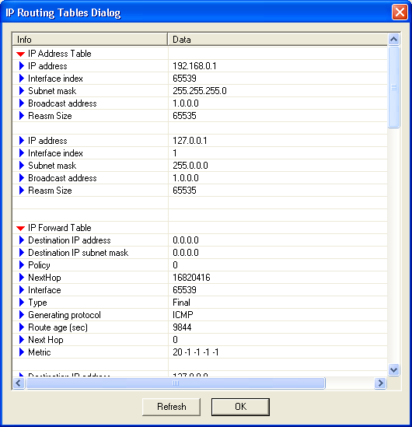

To refresh the dialog information click Refresh .

